

GR CLASS CLASSIFIED FOR STANDARD (GR CLASS)
SUPPLEMENT TO THE BOTTOM SURVEY INSPECTION REPORT

Periodical Survey
Initial Survey
(Annual) Renewal Survey
Additional
Survey (Occasional)

Name Of Ship | Port Of Registry |  | Gross Tonnage | Year Keel Laid
DISTINCTIVE NUMBER OR LETTERS |  | Patente Number And Date:
Details Of Persons Requesting Survey And To Whom Certificates Are To Be Sent
OWNERS/MASTER
AGENTS/OPERATORS

Date of Survey / commenced: completed: Name/Number of Surveyor: Place of Survey:

Date of dry-dock survey Intended date of next dry-docking

Rudder bearing clearances:

Rudder type:
(semi balanced or balanced rudder with heel, spade rudder / semi spade rudder / rudder supported by sole piece)

NAME OF SHIP | IMO | DATE | JOB REQUEST NUMBER

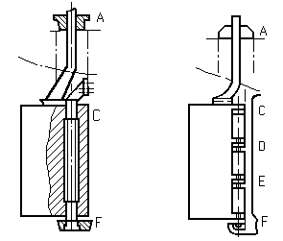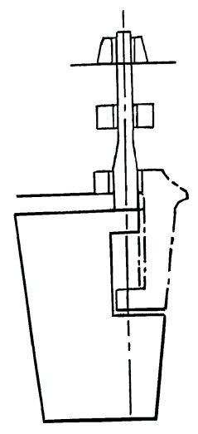
A
B C
D

Clearances in rudder Bearing (mm) |  | Neck Bearing | Upper Pintle | Lower Pintle | Bottom Pintle
Fore - Aft
Port – Stbd
Bearing Material | Bush
 | Liner

Stern tube bearing clearances:

Tail Shaft type:

(Tapered Shaft, Flanged Shaft)
Type of Shaft End: (Keyed, Keyless, Flanged) Type of Bearing & Material:
(Water or Oil Lubrication, Rubber, Lignum Vitae) Tightness test of the sealing was examined:
Periodical oil analysis certificates were performed and checked: Oil consumption and shaft bearing’s temperature records were
checked:

Date of next survey of propeller shaft:

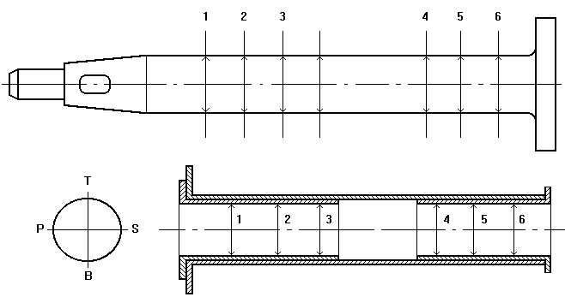
NAME OF SHIP | IMO | DATE | JOB REQUEST NUMBER

Initial Record of Clearances by feeler gauge
INNER BEARING | T-B
 | P-S
OUTER BEARING | T-B
 | P-S
END FACE GAP OF FLANGE | T-B
 | P-S

Tailshaft is a little higher/lower mm
Right/Left of Center mm

Position |  | 1 | 2 | 3 | 4 | 5 | 6
TAIL SHAFT | T-B
 | P-S
BUSH | T-B
 | P-S
CLEARANCE | T-B
 | P-S
Previous Clearances

Propeller:
Propeller type: (variable pitch/fixed pitch propeller)
Propeller fitting and nut securing were examined

BLADE1
BLADE3
BLADE4
BLADE2
NAME OF SHIP | IMO | DATE | JOB REQUEST NUMBER

Blades* | 1 | 2 | 3 | 4
Good
Regular
Poor
*Check for deformation, pitting, cracks, thickness of blades, fastenings and tightness of hub and blade sealings (if applicable)

SURVEYOR NOTES:
For negative entries, major repairs, alteration or modification of a major character, and recommendations if any, describe in detail:

Issued at: Date of Issue:

(Place of issue of certificate) (DD-MM-YYYY)

THIS IS TO CERTIFY THAT: This survey report is correct in all aspects

GR CLASS REPRESENTAIVE

